**1. Creating and Renaming Files/Directories**

**Create a directory named test_dir using mkdir.**

**Inside test_dir, create an empty file called example.txt.**

**Rename example.txt to renamed_example.txt using mv**

Explanation:

* mkdir creates a directory.
* touch makes an empty file.
* mv renames the file.

Screenshot:

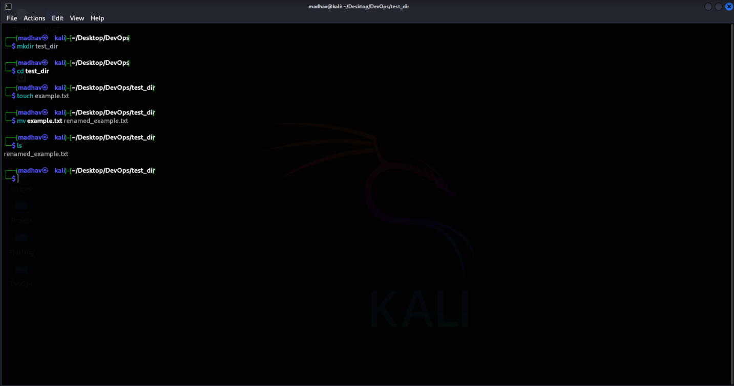

**2. Viewing File Contents**

**Use cat to display the contents of /etc/passwd.**

**Display only the first 5 lines of /etc/passwd using head.**

**Display only the last 5 lines of /etc/passwd using tail.**

Explanation:

* cat displays the whole file.
* head shows the first 5 lines.
* tail shows the last 5 lines.

Screenshot:

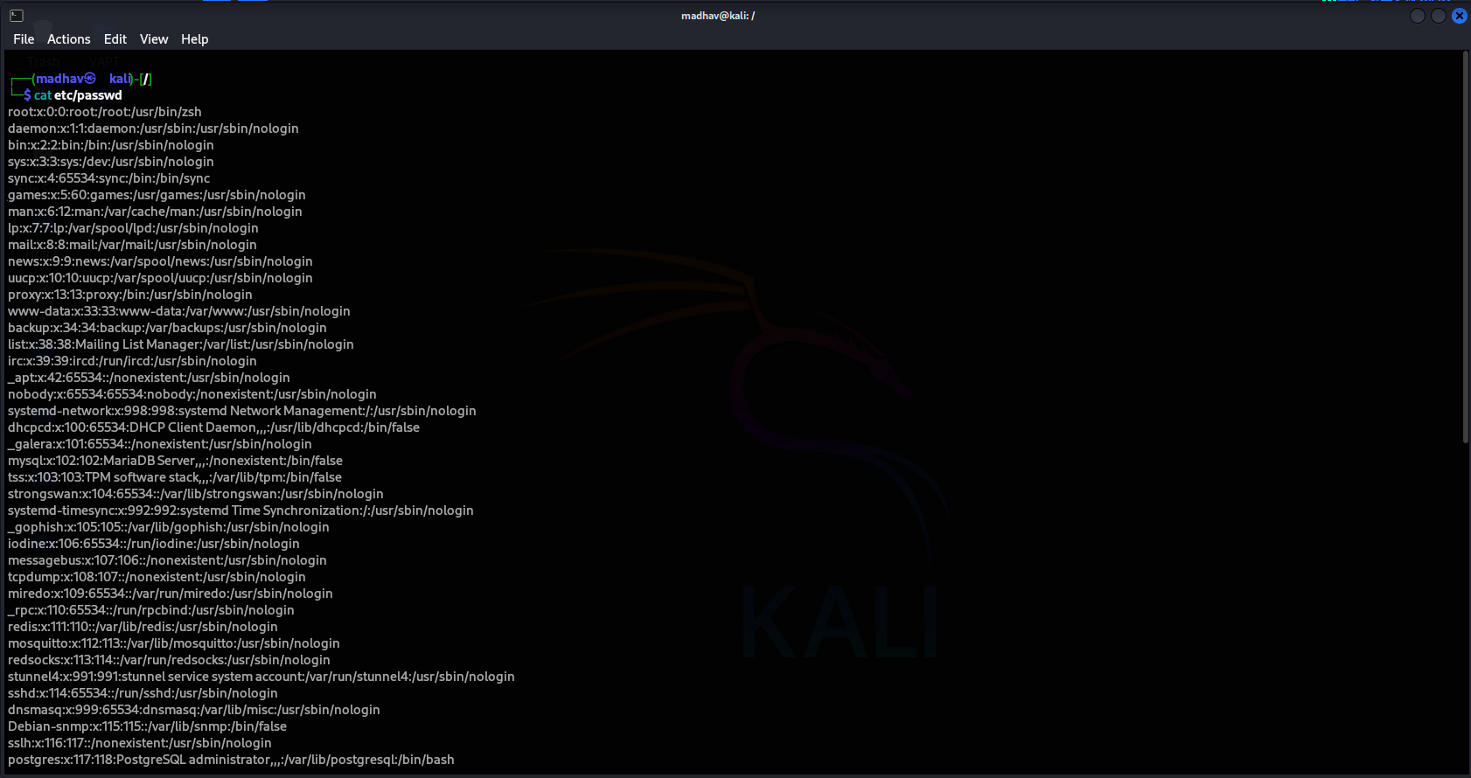

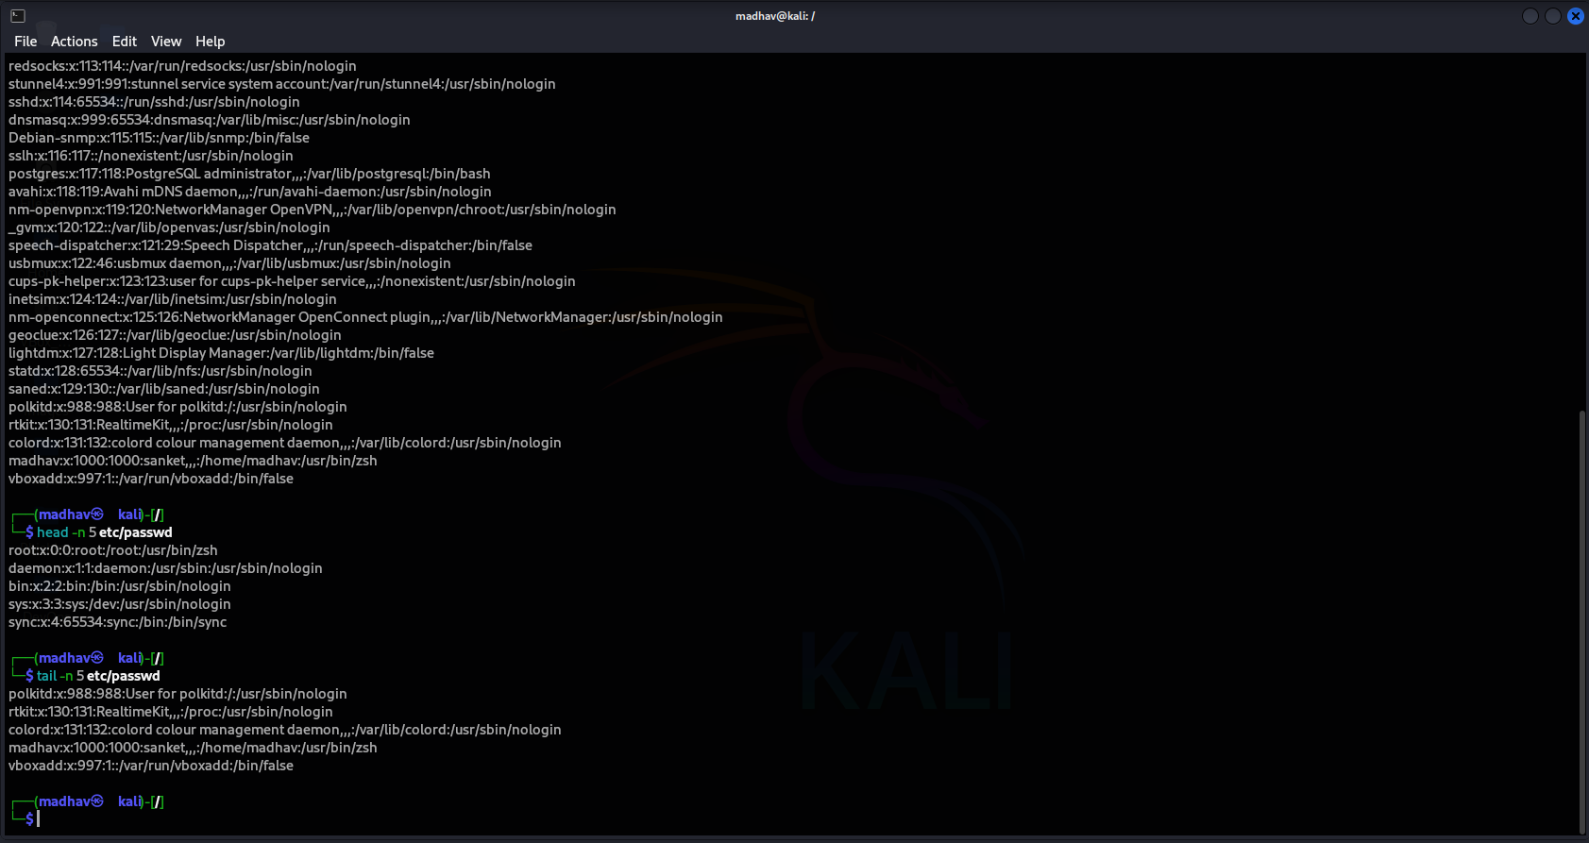

**3.Searching for Patterns**

**Use grep to find all lines containing the word "root" in /etc/passwd.**

Explanation:

Searches for the word "root" in each line of /etc/passwd.

Screenshot:

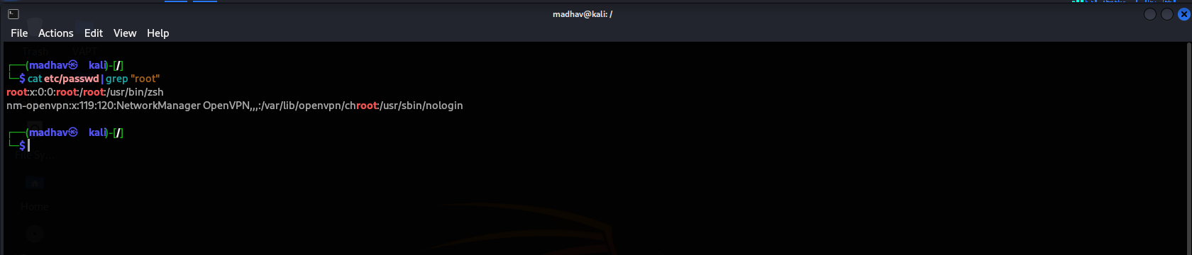

**4. Zipping and Unzipping**

**Compress the test_dir directory into a file named test_dir.zip using zip.**

**Unzip test_dir.zip into a new directory named unzipped_dir.**

Explanation:

* zip -r recursively zips a directory.
* unzip -d extracts it to a new folder.

Screenshot:

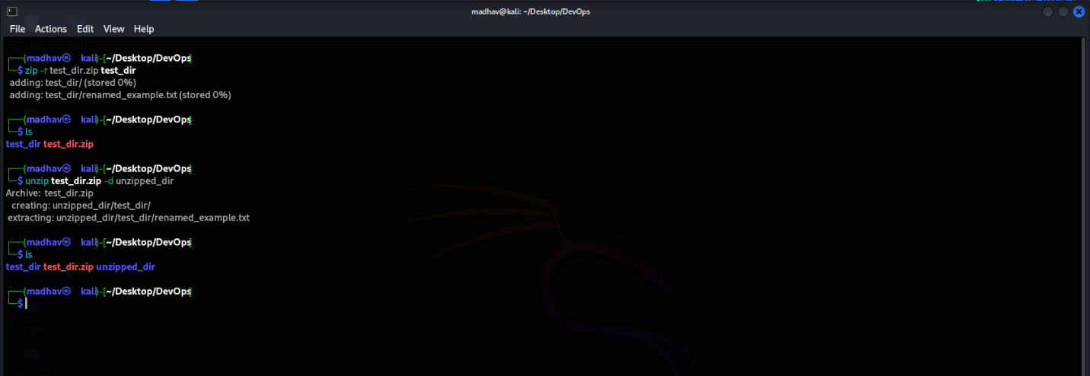

**5. Downloading Files**

**Use wget to download a file from a URL (e.g.,** [**https://example.com/sample.txt**](https://example.com/sample.txt)**).**

Explanation:

* Wget: Downloads file from the specified URL.

Screenshot:

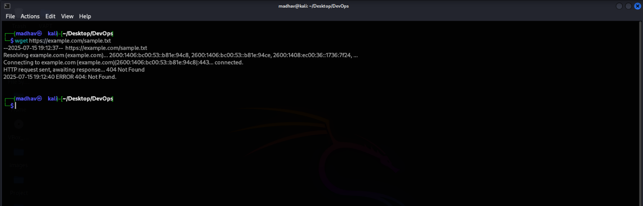

**6. Changing Permissions**

**Create a file named secure.txt and change its permissions to read-only for everyone using chmod.**

Explanation:

* touch makes an empty file named secure.txt.
* Makes the file read-only (4) for user, group, and others.

Screenshot:

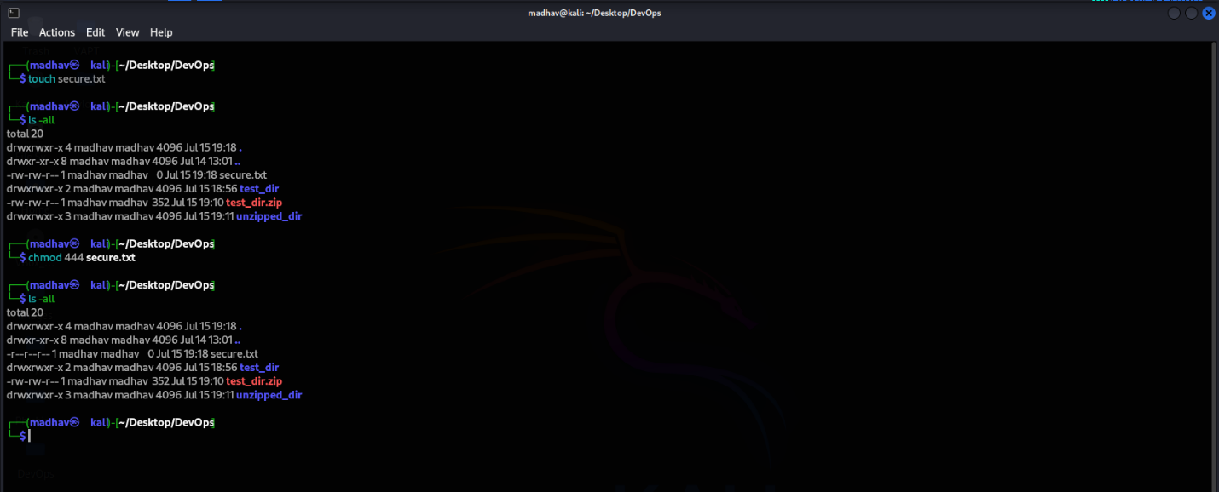

**7. Working with Environment Variables**

**Use export to set a new environment variable called MY_VAR with the value "Hello, Linux!".**

Explanation:

* Creates an environment variable MY_VAR.

Screenshot:

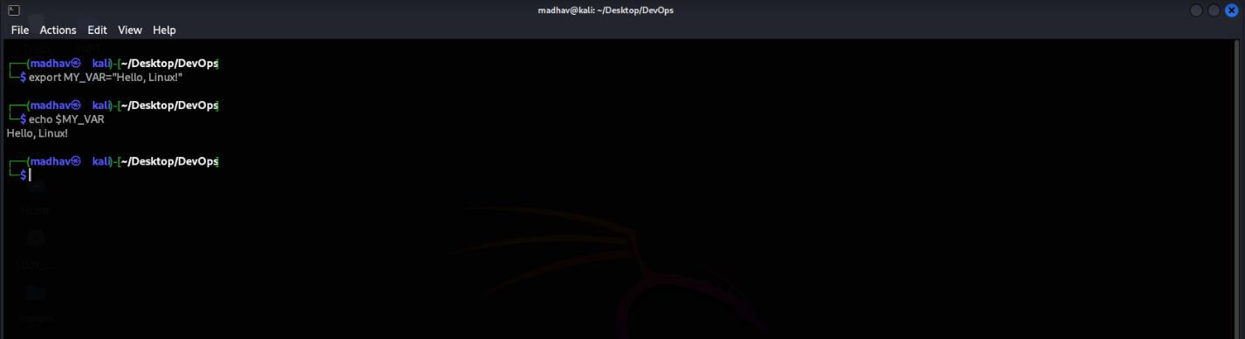

**GitHub Repo:** [**https://github.com/Sankett07/Linux-Basics_Assignment.git**](https://github.com/Sankett07/Linux-Basics_Assignment.git)